Lab Practical #13:
To develop network using distance vector routing protocol and link state routing protocol.
Practical Assignment #13:

- C/Java Program: Distance Vector Routing Algorithm using Bellman Ford's Algorithm.
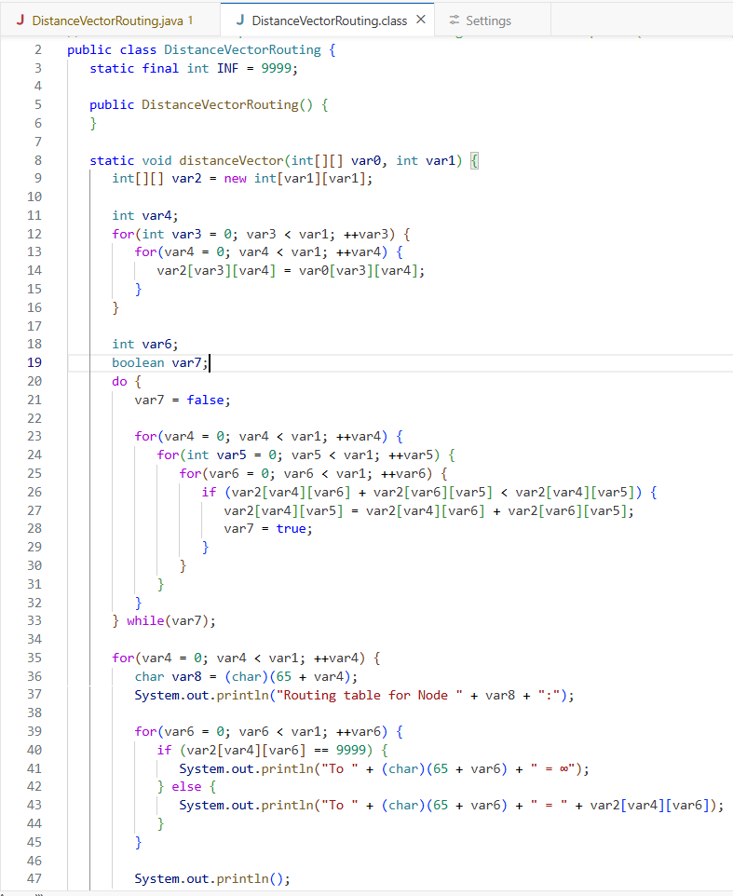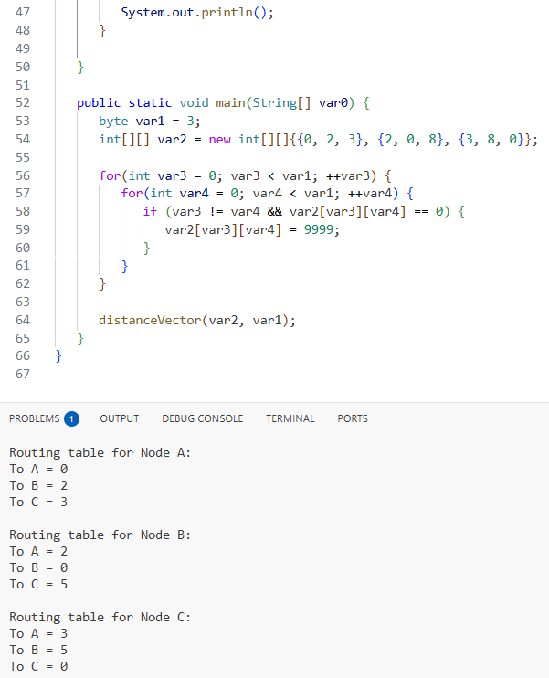

2. C/Java Program: Link state routing algorithm.

